Understanding document

For

TECH file

Version 1.0

# Introduction

## Purpose

A technical file is a set of documents that describes a product and can prove that the document was designed in accordance with the requirements of a quality management

*It guides physical design tool on below list of information:*

* Unit tile definitions that can be used in site rows so that placement engine can guide placement of cells
* List of metals available for routing
* Metal widths, spacing & pitch info etc.
* Design rules between same metal layer spacing
* What are all the via types/via masters available
* Units of length, power, resistance & technology precision etc.

**Section 1:**

* Below section contains details of the technology: like name, units, precision of grid etc.

Technology {

    Name                          =  "3nm"               # name of the Technology

(45, 40, 32, 28, 16, 14, 12, 10, 7, 3)

*Technology version and layers are indirectly proportional

*If the technology version upgrades layers will be more

    Date                            =  "2022/08/23"      # date on when this file got updated

    Dielectric (                     =  Value            # value of di electric constant of this

Technology

    Unit Time Name             = "PS"(picosecond)   # Time Units: though units from .lib are

Used for timing analysis, we still need to

Keep here for consistency!!

    Time Precision               = 1000                 # timing precision

    Unit Length Name          = "micron"                # physical dimension units

    Length Precision            = 1000                # precision of the physical drawn length

    Unit Voltage Name         = "V"                 # voltage units

    Unit Capacitance Name   = "ff"                 # capacitance Units (femto farad)

    Capacitance Precision       = 1000000         # details

  }

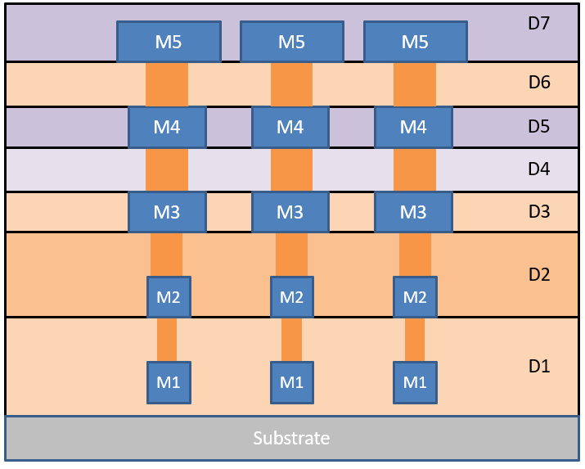

**Section 2:**

* Declare all type colors you may use in the design, red, green, blue etc..  (RGB)
* Once you go to metal layer definition section, you can assign these colors for metals using "color" options
* Color 1 {
* name                            = "chip"
* RGB Defined                      = 1 or 0
* red Intensity                    = 100
* green Intensity                  = 150
* blue Intensity                   = 200
* }

**Section 3:**

**# TILE (minimum height and width of the cell to be placed) definitions:** Most important info: unit tiles: based on these ICC site row definitions and standard cell placement happen

SITE ROW: Rows are multiples of site definition we can say that smallest unit of placement where the smallest cell can be placed.

* Can contain more than one type of tiles to accommodate diff scenario
* Tile "unit" {
* width                           = 0.5                 ; # min width  : X value
* height                          = 0.6                ; # min height : Y value
* }
* Tile "core" {
* width                           = 0.5                ; # same as above
* height                          = 0.6                ; # same as above;
* we can various tile declarations as per need, while creating site rows, use corresponding tile definition

}

**Section 4:**

#----------------------------------------------------#

**# Layer details:**

Details of layers: metal, via, diffusion, it contains: layer number, name, color, pattern, min width, pitch, DRC (Design rule check) with respect to next metal/via *

Layer "m2" {                                        # layer details start: layer is m0

Layer Number                     = xx         # layer number that will get shown on options while doing layout edits

##Mask Name                     = "metal3" # mask name

Can be used for verify lvs and also tech2itf

Comparisons. But m0 is the standard names used

For icc visual/internal routing

  Is Default Layer               = 1             # to denote if this is the default layer that ICC

Can use for physical implementation

  Color                              = "red"        # what color do you want see this metal or layer

  Pattern                           = "dot"         # what pattern: fill or dot or lines for this layer

  Line Style                       = "solid"     # boundary line is solid or transparent

  Visible                            = 1              # is it a visible layer

  Pitch                              = 1 # layer pitch, distance between center to center of

M0 shapes that can be allowed

  Min Width                      = 0.5     # min width of the layer that can be drawn by ICC

  Default Width                = 0.5      # what is the default width of the the layer

   Min Length                    =0.5      # how much is the min length of m0 can be drawn

   X Min Spacing               = 0.5     # what is the min spacing in x direction that another

M0 can

    Y Min Spacing               = 0.5     # what is the min spacing in y direction that another

    Corner Min Spacing          = 0.5     # m2 to m2 corner in another track allowed distance

At min is

    Min Spacing                       = 0.5    # details

    #Non Preferred Route Mode  = 1     # to denote ICC whether m0 can be used for non –

Preferred direction routes if required 1

Non-preferred routing 0

Routing can be in any

Direction

   # Ortho Spacing Exclude Corner = 1    # 1 means check only corner 2 corner space, not x

And y as well

**Via Contact Codes**#

Via master properties like layers, resistance, enclosure etc..

ContactCode "VIA2AB" {

contactCodeNumber               = 1

    Cut Layer                        = "via2"

    LowerLayer                      = "m1"

    UpperLayer                      = "m2"

    IsDefaultContact                = 1

    Cut Width                        = <value>

    Cut Height                       = <value>

    UpperLayerEncWidth             = 0.1

    UpperLayerEncHeight            = 0.0

    LowerLayerEncWidth             = 0.1

    LowerLayerEncHeight            = 0.1

    MinCutSpacing                     = 0.0

    UnitMinResistance                 = 0.1

    UnitNomResistance               = 0.1

    UnitMaxResistance                = 0.1

}

Example:

Name Type Number type RGB sell? vis? fill style line style  
LAYER pwell drawing 1 0 (150,150,217,255) t t empty plain ;  
LAYER nwell drawing 2 0 (170,0,255,255) t t empty plain ;  
LAYER diff drawing 3 0 (0,204,0,255) t t dots2 plain ;  
LAYER od2 drawing 4 0 (217,204,0,255) t t dots2 plain ;  
LAYER poly1 drawing 13 0 (255,0,0,255) t t zagr1 plain ;